**Project Title: Implementation Of Chatbot Using NLP**

**Week 1. Project Planning and Data Preparation**

The project planning and data preparation phase is one of the most critical stages in any machine learning project. For a **Chatbot Implementation using NLP**, we will follow a structured approach to ensure that the chatbot is functional, accurate, and responsive to user inputs. The goal is to develop a chatbot capable of understanding and responding to user queries using NLP techniques, which can be classified into various intents, with an appropriate response.

**Define the Business Problem and Project Objectives**

* **Business Problem**

In the modern digital world, customer interaction through websites, applications, and social media is becoming increasingly frequent. One of the most important aspects of customer interaction is **efficient communication**. Many businesses are leveraging chatbots to provide instant support and automate interactions with customers. However, creating a highly functional chatbot that can understand varied queries, interpret the intent behind the user's input, and deliver the appropriate response is still a challenge.

The **business problem** this project aims to solve is how to implement a **chatbot system** that:

* **Classifies user inputs** into predefined **intents** (e.g., greetings, questions, etc.).
* **Generates accurate responses** based on these intents.
* **Improves customer experience** by providing **real-time, automated responses**.
* **Project Objectives**

The objective of this project is to develop a chatbot using **Natural Language Processing (NLP)** techniques to automatically understand and respond to user inputs. The detailed objectives are:

* **Data Collection**: Gather datasets related to the target domain for training the chatbot (e.g., customer queries, frequently asked questions).
* **Data Preprocessing**: Clean the collected data and preprocess it for training by handling missing values, removing noise, tokenizing text, and transforming text into numerical features.
* **Feature Engineering**: Use **TF-IDF vectorization** or other methods to convert raw text into numerical data.
* **Model Training**: Train a machine learning model (e.g., **Logistic Regression**, **SVM**) to classify user inputs based on their intent.
* **Model Evaluation**: Evaluate the chatbot’s performance using various metrics (e.g., accuracy, precision, recall).
* **Implementation of User Interface**: Create a user-friendly interface (using tools like **Streamlit**) where users can interact with the chatbot.

**Tools and Software**

* **Hardware Requirements:-**
* The project can be run on standard hardware(laptops/desktops) with this requirements
* **Processor**: Intel Core i3 or equivalent (minimum).
* **RAM**: 8 GB or more.
* **Disk Space**: 2 GB of free space (for datasets and tools).
* **Software Requirements:-**
* **Python** 3.x (preferred version: 3.7 or later).
* **Libraries**:

**1.NLTK (Natural Language Toolkit)**

* **Purpose**:  
  NLTK is used for **tokenization**, which splits guest queries into individual words. This helps the system to understand the **context** and meaning of the input text.
* **Use Case**:  
  In the **hotel chatbot** system, NLTK is used to tokenize the **user's input** and match it with **predefined patterns** to identify the intent (e.g., dining request, check-in inquiry, etc.).
* **Additional Detail**:  
  The nltk.punkt dataset is loaded for tokenization, which ensures words are processed correctly. This helps in matching the user input to stored patterns, even if the query is worded differently.

**2. scikit-learn**

* **Purpose**:  
  **scikit-learn** is used for machine learning tasks, including **vectorization** of text data and **training** classification models. It provides tools to transform textual data into a numerical format that the machine learning model can understand.
* **Use Case**:  
  In the chatbot, scikit-learn is used to convert text into numerical **features** (using **TF-IDF vectorization**), and it trains the **Logistic Regression** model to predict the user intent based on the input query.
* **Additional Detail**:  
  The **TfidfVectorizer** from scikit-learn helps convert the tokenized words into numerical features. The model is then trained on these features to classify user inputs into intents.

**3.Streamlit**

* **Purpose**:  
  **Streamlit** is used for building **interactive web applications**. It allows quick prototyping of front-end interfaces without needing complex web development skills.
* **Use Case**:  
  In the chatbot, **Streamlit** is used to create a **web-based interface** where users can type their queries and receive responses from the bot in real-time.
* **Additional Detail**:  
  Streamlit allows rapid development of a user-friendly interface. The chatbot responds to the user's input and displays the response instantly.

**4. Pandas**

* **Purpose**:  
  **Pandas** is a powerful library used for **data manipulation** and **cleaning**. It provides easy-to-use data structures like DataFrames for handling and processing structured data.
* **Use Case**:  
  Pandas is used to load and process the **intent dataset** (e.g., JSON file), clean the data, and transform it into a format suitable for training the chatbot model.
* **Additional Detail**:  
  Pandas can be used to inspect and clean the data by handling missing values, ensuring all patterns and responses are structured correctly for training.

**5. NumPy**

* **Purpose**:  
  **NumPy** is a library for numerical operations and matrix manipulation, often used in machine learning for handling **arrays and matrices** efficiently.
* **Use Case**:  
  NumPy is used to handle **numerical data** and perform efficient **array operations**. In the context of the chatbot, it helps in handling **feature arrays** and performing mathematical operations during model training.
* **Additional Detail**:  
  NumPy allows quick array manipulation, which is essential for working with the **feature vectors** generated by TF-IDF and for training machine learning models.
* **NLTK** is used for **tokenization** and processing text inputs.
* **scikit-learn** handles **text vectorization** (TF-IDF) and **training** the machine learning classifier (Logistic Regression).
* **Streamlit** provides a **web interface** for real-time user interaction with the chatbot.
* **Pandas** is used for **data manipulation**, **cleaning**, and handling the dataset.
* **NumPy** helps in performing **array operations** and working with numerical data.

**IDE**: Jupyter Notebook, PyCharm, or VS Code.

* **Tools Usage**
* **Python Programming**: Used for developing machine learning models, preprocessing data, and implementing the chatbot logic.
* **Natural Language Processing (NLP)**: To preprocess text data (tokenization, lemmatization), and convert it into meaningful features.
* **Machine Learning Algorithms**: Logistic Regression, SVM, or other classifiers for intent classification.
* **Streamlit**: To create the chatbot’s interactive web interface.

**Gather Relevant Datasets and Explore Potential Data Sources**

* **Dataset Collection**

For the chatbot to be trained on various user inputs, we will need a dataset that contains **patterns (user queries)** and **corresponding intent labels**. Some options include:

1. **Custom Dataset**: You can collect data directly from customer interactions, support tickets, or FAQs.
2. **Public Datasets**: There are several publicly available datasets for chatbot training, such as:
   * **Intent Classification Datasets**: Kaggle provides datasets for intent classification, where each user query is mapped to a specific intent.
   * **Snips NLU Dataset**: A popular dataset for intent classification tasks in natural language processing.
   * **Rasa Datasets**: Rasa provides both intents and examples for chatbot development.

* **Exploring Data Sources**

Once the dataset is gathered, it is important to explore the structure of the data:

* **Pattern**: The actual user input (e.g., "How do I reset my password?").
* **Intent**: The label corresponding to the user input (e.g., "password_reset").
* **Response**: The response message for the given intent.

Example:

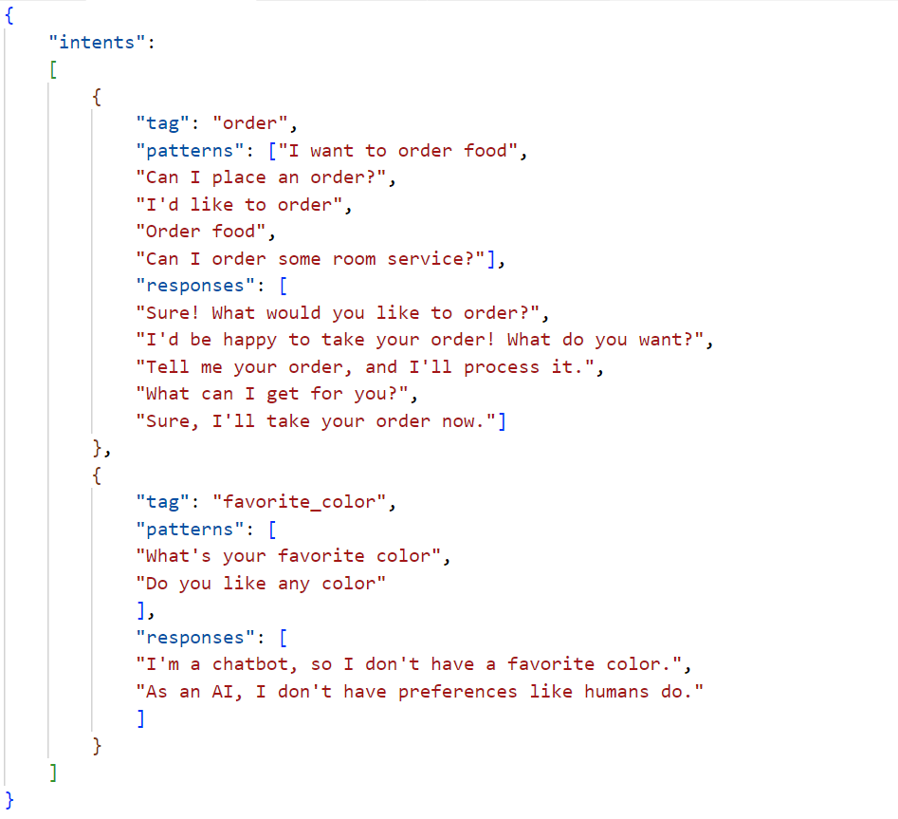

**Clean and Preprocess Data**

* **Handling Missing Values**

The dataset might contain missing values. If any field (such as patterns or responses) is empty or null, it must be addressed:

* **Remove** incomplete records, if they are few.
* **Impute** missing data, if necessary, using default patterns or responses based on other similar entries.
* **Data Cleaning**
* **Lowercasing**: Convert all text to lowercase to standardize inputs.
* **Removing Special Characters**: Eliminate characters like punctuation, symbols, or any irrelevant text.
* **Tokenization**: Break the sentences into words (tokens) to simplify processing.
* **Removing Stopwords**: Remove common words such as "the", "is", "on" that do not provide value in text classification.
* **Lemmatization**: Reduce words to their base or root form (e.g., “running” to “run”).
* **Data Transformation**

Once cleaned, the data needs to be converted into a numerical format that can be fed into machine learning models:

* **TF-IDF Vectorization**: This technique transforms text into numerical vectors, where each word's importance is measured based on its frequency across documents.
* **Label Encoding**: Convert categorical labels (intents) into numerical labels using **LabelEncoder** from sklearn.

**Exploratory Data Analysis (EDA)**

* **Visualizing Data**

Before training the model, it’s essential to gain insights from the dataset:

* **Class Distribution**: Check if the dataset is balanced across intents. If there are some intents with fewer samples, you might need to handle class imbalance by oversampling or undersampling.
* **Word Frequency**: Plot the most common words in the dataset to identify any dominant words or phrases that could affect the training.
* **Pattern Length Distribution**: Understand the average length of user queries to know if there’s significant variation.
* **Data Insights**
* **Intent Distribution**: Identifying intents with too many or too few patterns could inform adjustments in the dataset.
* **Frequent Words**: If certain words appear across all intents, it could suggest redundant information that should be filtered.
* **Query Complexity**: If most queries are very short, it might be helpful to add variations and more complex queries for better model training.

**Data Splitting**

* **Data Splitting Process**
* **Training Set (70%)**: Used for training the machine learning model.
* **Validation Set (15%)**: Used for tuning hyperparameters and selecting the best model.
* **Test Set (15%)**: Used to evaluate the model’s performance on unseen data to simulate real-world interactions.

**Knowledge of Data Modeling**

* **Data Sources:** The intents dataset (in JSON format) provides structured data that links user queries with corresponding responses.
* **Data Preprocessing:** Key steps include tokenization (breaking text into words) and similarity matching (handling variations in user input).
* **Feature Engineering:** TF-IDF transforms raw text into useful numerical features.
* **Model Training:** A classifier is trained on preprocessed data to predict user intents.
* **Evaluation**: Using performance metrics like **accuracy, precision, recall, and F1-score** to assess the chatbot’s effectiveness.